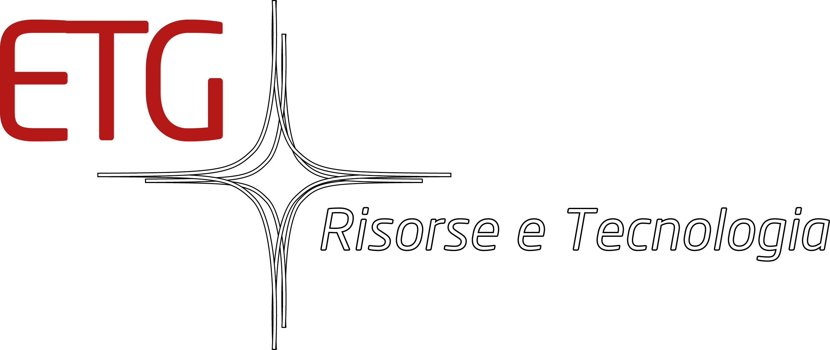

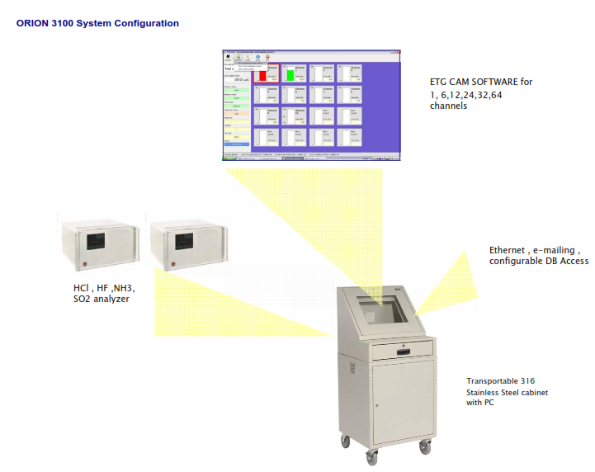
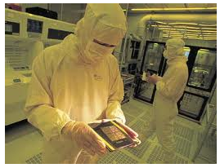
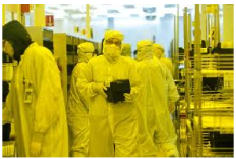
A reliable partner in gas analysis & monitoring
ETG Risorse e Tecnologia
New Orion 3100
AMC Trace Ammonia, HF, HCl, Gas monitoring for Semi-Application
HIGHLIGHTS

- Real-time at sub-ppb measurements

- CEAS principle of operations

- Continuous, unattended operation in harsh or hazardous environments

- No reagents, radioactive source, paper tape, absorbent tubes
or other expensive consumables for operation

- Long-term stability and reliability

- Solid-state electronics and no moving parts

- Low maintenance for maximum uptime

- Every monitor is shipped factory-calibrated with an applications performance specification.

- CEAS analyzers for single/multiple trace gas compounds detection

- Multipoint sampling from 4 to 64 channels

- Programmable Alarm and Fault Relays with Individual Programmable Alarm Levels

- Programmable Sample Point Sequencing with Individual Channel Purge and Analysis

- Open Communication Protocol for easy integration to existing systems

- No Data loss during power interruption or shutdown

- Touch-screen display allows Graphic and
Operator functions to be changed or updated easily

- Connections ¼ “ OD

- Piping : PFA, PVDF

- Max length pipe line for each channel measured : 80 mt

- Panel PC colour VGA touch screen which allow graphic and operator functions

- Remote visualization and operation by Radmin Software or similar

- Any carrier or special utilities

- Output signal : Standard : RS232 , Ethernet Optional : 4-20 mA, Modbus

- Electrical supply : 115-230 Vac 50/60 Hz

- Calibration verification by optional

- Calibration with Permeation generator

- Sampling by Sample & Fast loop pump

The Deep Ultraviolet (DUV) lithography process has proven to be especially sensitive to many types of molecular level contaminates. Ammonia, and acid gases are known to create problems throughout the fab.
The development of improved DUV Resist materials and long-life filters has not lessened the need for continuous real-time monitors, in fact it has made the measurement of airborne contaminants critically important.
The use of the ORION 3100 based on CEAS Series Analyzer will improve resist uniformity, guarantee maximum filter life, and reduce process downtime.

ETG HMI (Human Machine Interface) software allows real-time viewing, manipulation, and automation of ammonia, HCl, HF analyzer that are sampling from several different locations. This software program was written for semiconductor facilities attempting to monitor and control airborne contamination in the DUV lithography process. This software has the flexibility to be applied to any industrial setting where multipoint sampling by one or more CEAS analyzers is needed. Features include easy interactive control of alarms, data
logging, historical trending, and basic analyzer functions from a Windows environment.

< Back to Product List
Checking the filter investment

The installation of chemical filters either on the recirculating air system of the cleanroom air or on the tools represents a big economic investment. Filter replacement according to a set maintenance scheme could unnecessarily increase an already high cost if working filters are changed too early or it could cause inadequate protection if exhausted filters are changed too late. With up to 16 channels, the µ-VOC system allows monitoring both upstream and downstream of the filters. The sample point upstream detects when the incoming air is not within the filter specification, while the monitoring point downstream indicates when the absorbing capability is exhausted.
A process tool

The µ-VOC system has been designed to be an analytical process tool for continuous unattended operation. It automatically samples up to 16 pointsand for each of them different alarm can be set. Its capability to be transportable, makes of the µ-VOC system a very useful tool to understand contamination monitoring causes.. On board calibration is included, to match the stringen quality control rules. Results are displayed in real time and are expressed as concentration values, with no calculation to be run Remote connection to the customer’s network is provided as standard

Theory of Operation

GC has long been the technology of choice when complex molecules need to be separated and identified. This method depends on the volatilization of a complex sample and an equilibrium of absorption of the various components by the stationary phase of a chromatographic column As the components elute from the column they are monitored by the change in electrical conductance by a hydrogen/air flame ionization detector (FID). The FID will reflect the presence of organic compounds. The unique purge and trap system of sampling allows sub-ppb detection limits.

